SDLC (SOFTWARE DEVELOPMENT LIFE CYCLE )

1. REQUIREMENT ANALYSIS & PLANNING:( arrange by PRODUCT MANAGER & BUISSINESS ANALYST )

> what customer want . scope ,aim ,requirements of project .

> create SRS (Software Requirement Specification) .

> Risk management .

> cost estimation & other resources .

2. DESIGN :(by PRODUCT MANAGER & UI/UX DESIGNER )

> Create a architecture diagram i.e. to do work list . creating module .

> HIGH LEVEL DESIGN: Categories in app,

> LOW LEVEL DESIGN: input and output of categories.

3. IMPLEMENTATION:( DEVELOPER )

> Selecting right software language for the modules .

4. TESTING:( QA TEAM / TESTER )

> Checking bugs and if any fixing them.

5. DEPLOYMENT:( PROJECT MANAGER & SUPPORT TEAM )

> After all the processes making the software available for use.

6. MAINTENANCE:( PROJECT MANAGER & SUPPORT TEAM )

> Ensuring that the software works properly .

1. WATERFALL MODEL OF SDLC

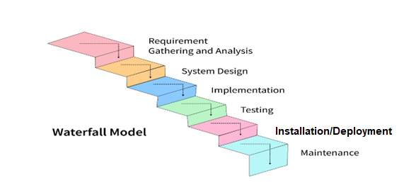

ADVANTAGES:

* Introduced by WINSTON ROYCE in 1970 .
* Also called linear sequential development model .
* Easy to use .
* One step must be completed before next one begins .
* Proper documentation maintained .
* Best for project with clear vision and no changes gonna happen in future.

DISADVANTAGES:

* No changes can be done after a stage completed .
* Takes more time .

1. V MODEL:

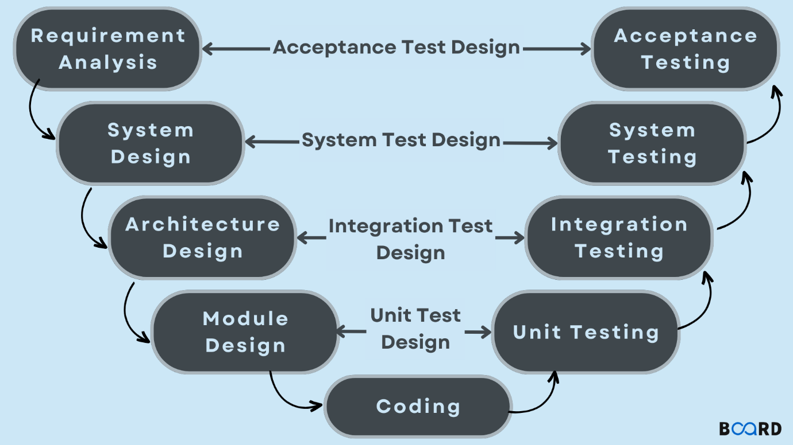

. As shown in figure every development stages have their corresponding testing phases , which helps on early detection of defects .

. It also known as verification and validation model .